EXPLORE THE WORLD WITH SHEAFE’S FLAT BLUEBIRD
Due: Friday, March 30, 2012
STUDENT NAME: _________________________________________________ ROOM _______________
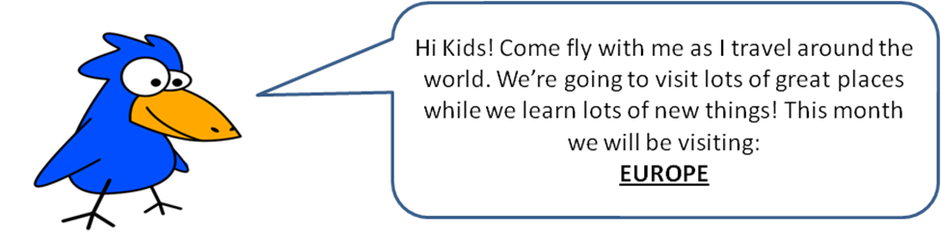
When you left me last week, do you remember what country I was visiting? That’s right, I was in Russia, the largest country in the world! This week, I’m back in England. Remember where Ireland and England are on the map of Europe? Ireland and England are the two islands under the word Europe. England is the bigger island. Come along with me on this week’s journey. From the southern tip of England, go east. There are two smaller countries. The Netherlands is the northern country and Belgium is directly south of The Netherlands. (Germany borders both The Netherlands and Belgium to the west.) South of Belgium is the country of France. I’ve already spent some time there so this time I’ll just be flying through. Switzerland is the country east of France and north of Italy (the country that looks like a boot). And, Austria is the country directly east of Switzerland. From Austria, I’ll fly south through Italy (all the way to the bottom of the boot), then cross over the Ionian Sea, which is really part of the Mediterranean Sea. I’ll land in the country of Greece. Look on the back to find out about Greece.
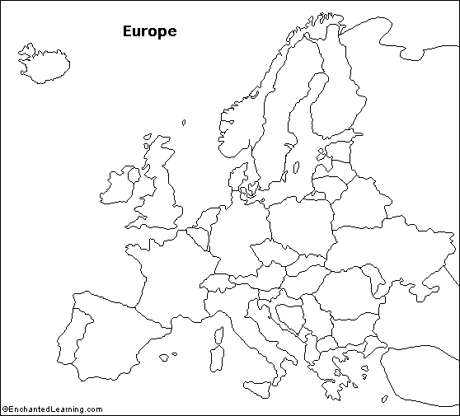
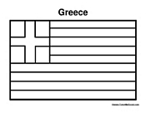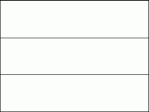

Using the information above and the compass rose, color and label the following countries:
The Netherlands – green
Belgium – yellow
Switzerland – purple
Austria – pink
Greece -- orange

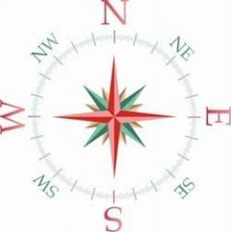

The Netherlands
The flag of the Netherlands has the same three colors as an American flag. Red is the top color, followed by white and blue is the bottom color.
The flag of Greece has two colors – bright blue and white. The cross is white on a blue background. The top stripe is blue, followed by a white stripe. The pattern continues, blue, white, ending with a blue stripe on the bottom.

Greek Trivia
Ancient Greece was a land of gods and heroes, great temples and great ideas. What do you know about ancient Greece. With adult permission, do some research and see if you can find out the answers to the following questions. Good luck!
- The Greeks invented a form of government which we still use today. What is it called?
- Communism b. Oligarchy c. Kingdom d. Democracy

- Which of these was a famous ancient Greek city?
- Paris b. Rome c. Athens d. London

- This building was dedicated to the goddess Athena. The temple had a huge statue made out of silver and ivory.
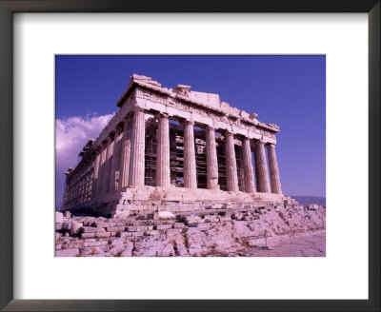
What is the name of the temple and what was it built on?

- What do we call the stories the Greeks told about their gods and heroes?
- stories b. cartoons c. tales d. myths

2. What is the capital city of Russia?
3. This famous Russian wrote the music to “The Nutcracker” ballet. What is his name?
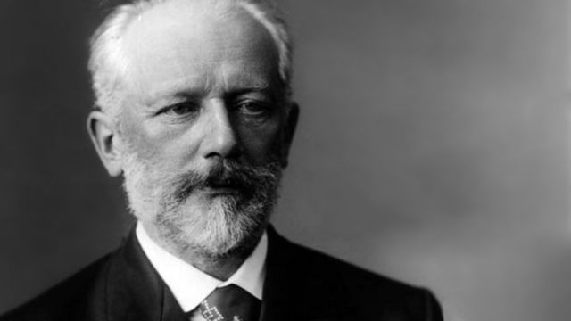
4. This famous Russian leader was the President of the USSR from 1988 – 1991. He won the Nobel Peace Prize and helped to end the Cold War.
